Intermediate HTML <https://www.udemy.com/course/the-complete-web-development-bootcamp/learn/lecture/37349778#overview>

**18 List Elements**

Unordered list

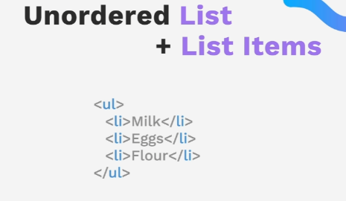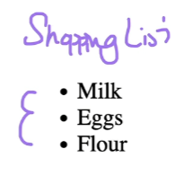

Ordered list

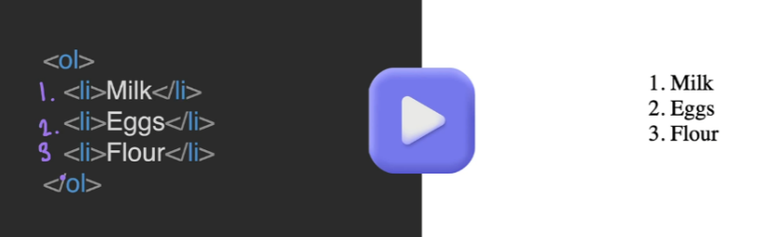

**19 Nesting and indentation list in a list**

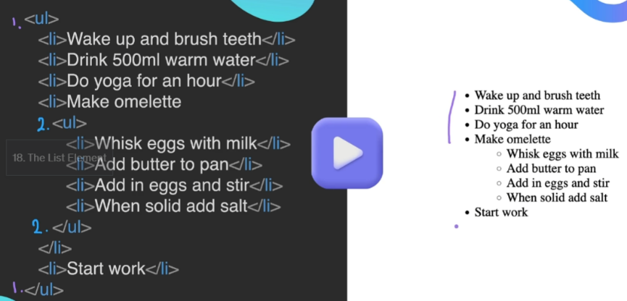

**20 Anchor Elements and hyperlinks**

The href attribute 

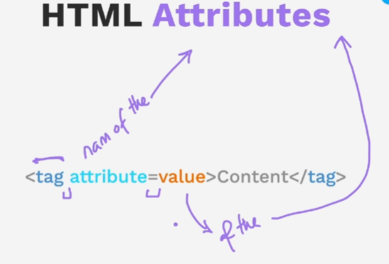

Can have more than one attribute , just separate by a space

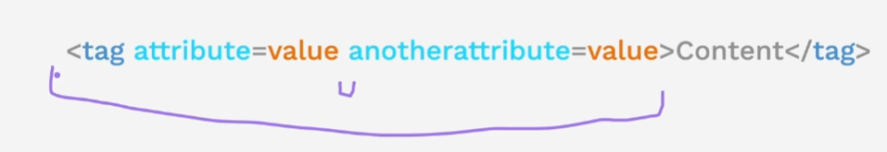

Target web site goes in the haref

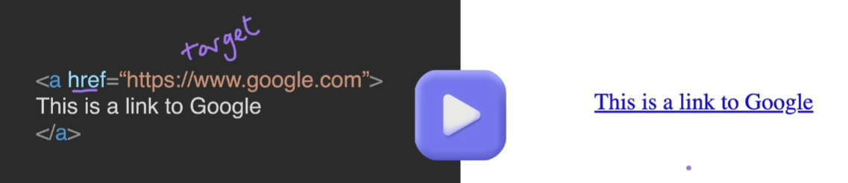to make dragable

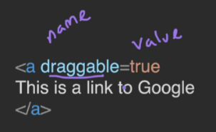

Starts list at number 6

<ol start="6">

  <li><a href="google.com">Google</a></li>

</ol>

<https://www.producthunt.com/>

21 Image Elements – its self closing , source attribute = in quotes, don’t forget the alt attribute

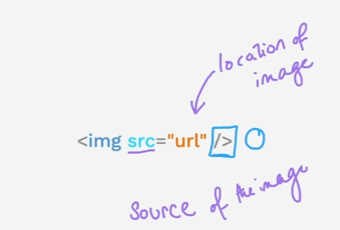

Lorem picum

<https://picsum.photos/>

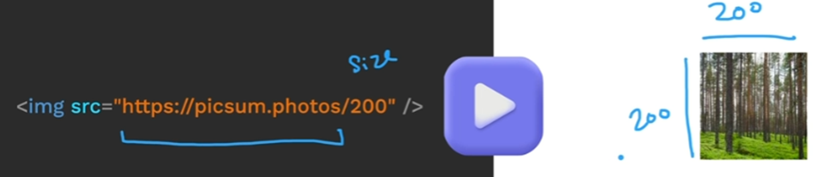

Silktide toolbar screen reader simulator

21 Birthday Party invite

Ask about

rel="noopener noreferrer"

Restart here

<https://www.udemy.com/course/the-complete-web-development-bootcamp/learn/lecture/37349924#overview>